EN
INSTRUCTION MANUAL

Quick Charger

BGCA-12BQ2-ZH
Power tool

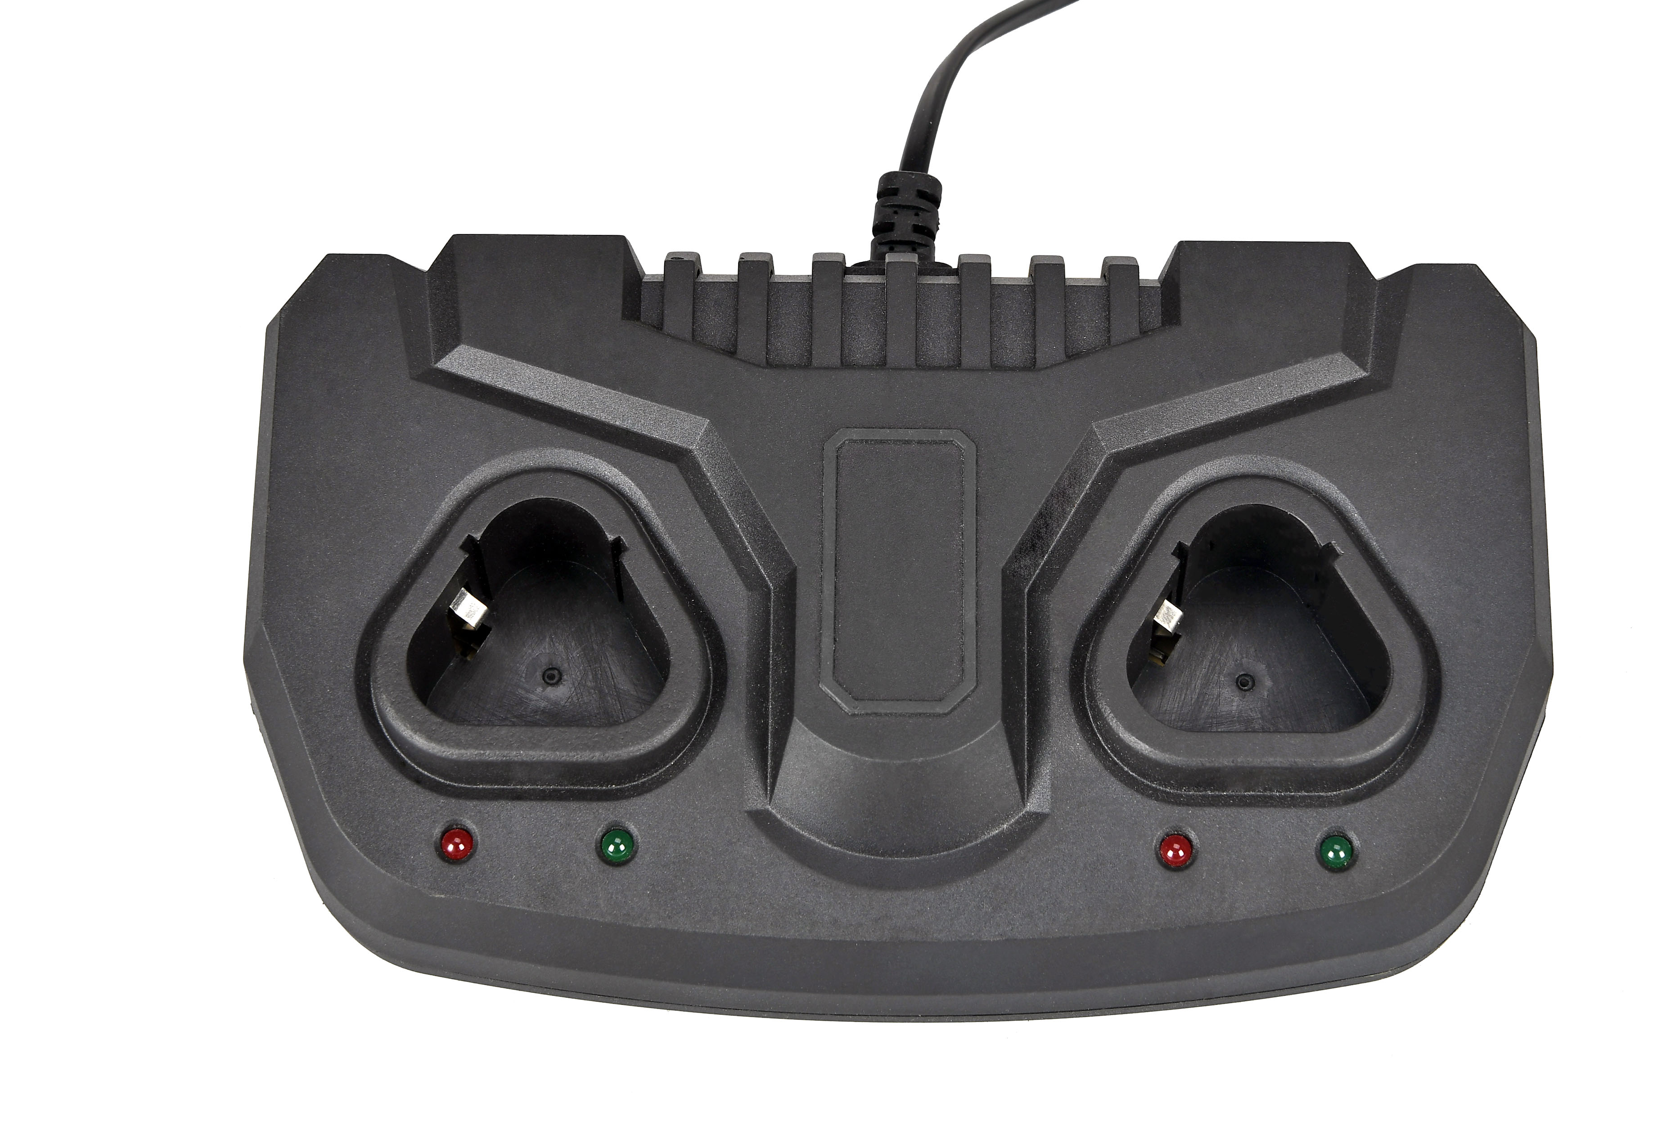

DESCRIPTION OF THE SYMBOLS
The use of symbols in this manual is intended to draw your attention to possible risks. The safety symbols and the explanations that accompany them must be perfectly understood. The warnings in themselves do not remove the risks and cannot replace correct actions for preventing accidents.


WARNING – To reduce the risk of injury, user must read instruction manual.
Before any use, refer to the corresponding section in this user manual.


Class II transformer.

For indoor use only.

Fuse

Polarity of the output terminal.


The crossed-out wheeled bin symbol indicates that the item should be disposed of separately from household waste. The item should be handed in for recycling in accordance with local environmental regulations for waste disposal. By separating a marked item from household waste, you will help reduce the volume of waste sent to incinerators or land-fill and minimize any potential negative impact on human health and the environment.

LIST OF MAIN PART
1
1. Charging indicator

TECHNICAL SPECIFIATIONS

Battery charger
Model | BGCA-12BQ2-ZH
Rated input voltage | 220-240V~,50-60Hz
Rated input power | 100W
Rated output voltage | 12V
Rated output current | 2.4A
Charging time | 1 hour
Protection class II
For indoor use only

OPERATION
Before use
Remove any packing material and loose parts from unit.
Check the accessories before use. It should be fit with the machine and your purpose.
If the machine is new, the battery must first be charged.

Battery charger
The power voltage supply must conform to that specified on the rating plate of the rapid charger.
Always inspect battery charger, cord and plug before use.
Always have damage repaired by a qualified professional.
Protect battery charger against humidity and operate only in dry areas.
The supplied charger is suitable for charging batteries only.
Charging the battery
To start the charging process plug the charger into the battery, then plug in the battery charger to the main
The battery and charger become warm during the charging process, this is normal.
After termination of the charging process, pull charger plug out of mains socket unplug charger from battery.

LED indicator on charger: red indicator: charging.
green indicator: charge finished.
About the charger
Disconnect the feeding before connecting or disconnecting the battery
The charger must be used only with rechargeable battery. Never use un-rechargeable battery.
Do not expose the charger to rain or water

MAINTENANCE

Always remove the battery before carrying out any work on the machine.
Care and cleaning
Keep the ventilation openings clear and clean the product regularly. Clean the housing only with a damp cloth-do not uses any solvents! Dry thoroughly afterwards.
Caution!
If something unusual occurs during use, switch off the tool and remove the battery. Inspect and repair the tool before using it again. Repair of the tool must only be carried out by a qualified repair technician.
Repair or maintenance by unqualified personnel can lead to a risk of injury.
Use only identical spare parts for repairing a tool.
Caution!
Ensure that the batteries are charged using the correct charger recommended by the manufacturer.
Attention!
After long time storage, the battery capacity will be reduce.
In order to maintain battery capacity, we recommend that only store full charged batteries and top-up the charge from time to time. They should be stored in a dry and frost-free place, the ambient temperature should not exceed 40 ⁰C.

STORING
Store the machine, operating instructions and where necessary the accessories in the original packaging. In this way you will always have all the information and parts ready to hand.
Pack the device well or use the original packaging in order to avoid transit damage.
Always keep the machine in dry place.

